Residual V1

0. Environment

|  |  |
| --- | --- |
| DataSet | CIFAR-10 |
| Language | Python3.5 & Tensorflow 1.0 |
| optimizer | Adam |
| Loss function | Cross entropy Loss |

Input : 32x32x3 size image

1. initialize

|  |  |
| --- | --- |
| layer | 3x3 conv (filter = 64, pad) |
| output | 32x32x64 |

2. module (5 times)

|  |  |
| --- | --- |
| Layer | 3x3 conv (filter = 64, pad) |
| Output #1 | 32x32x64 |
| Layer | relu |
| Output #2 | 32x32x64 |
| Layer | 3x3 conv (filter = 64, pad) |
| Output #3 | 32x32x64 |
| Layer | Output #3 + Input #1 |
| Output #4 | 32x32x64 |
| Layer | relu |
| Output | 32x32x64 |

3.Fully Connected

|  |  |
| --- | --- |
| layer | 3x3 average_pool(pad) |
| output | 32x32x64 |
| layer | Affine (Weight = 32x32x64, 1000) |
| output | 1000 |
| layer | Affine (Weight = 1000, 10) |
| output | 10 |

4. Overall

|  |  |
| --- | --- |
| Training(7600 iteration) | Time : 19832.265106201172 seconds |
| Accuracy : 0.61 |
| Validation | Accuracy : 0.593 |
| Re-training(64 iteration) | Accuracy : 0.661 |
| Re-Validation | Accuracy : 0.593 |
| Test | Acurracy : 0.599 |

Training

Iteration 0: with minibatch training loss = 75.1 and accuracy of 0.11

Iteration 100: with minibatch training loss = 2.26 and accuracy of 0.094

Iteration 200: with minibatch training loss = 2.33 and accuracy of 0.12

Iteration 300: with minibatch training loss = 2.19 and accuracy of 0.17

Iteration 400: with minibatch training loss = 2.17 and accuracy of 0.11

Iteration 500: with minibatch training loss = 2.21 and accuracy of 0.078

Iteration 600: with minibatch training loss = 2.08 and accuracy of 0.22

Iteration 700: with minibatch training loss = 2.04 and accuracy of 0.2

Epoch 1, Overall loss = 29.1 and accuracy of 0.179

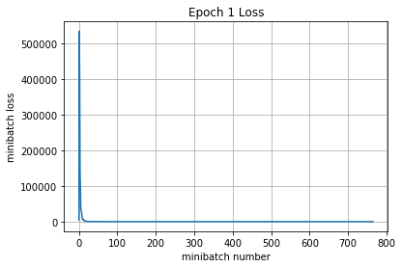

Iteration 800: with minibatch training loss = 2.07 and accuracy of 0.31

Iteration 900: with minibatch training loss = 2.14 and accuracy of 0.25

Iteration 1000: with minibatch training loss = 1.96 and accuracy of 0.31

Iteration 1100: with minibatch training loss = 2.05 and accuracy of 0.25

Iteration 1200: with minibatch training loss = 2.22 and accuracy of 0.28

Iteration 1300: with minibatch training loss = 1.98 and accuracy of 0.23

Iteration 1400: with minibatch training loss = 1.87 and accuracy of 0.3

Iteration 1500: with minibatch training loss = 1.97 and accuracy of 0.28

Epoch 2, Overall loss = 2.01 and accuracy of 0.269

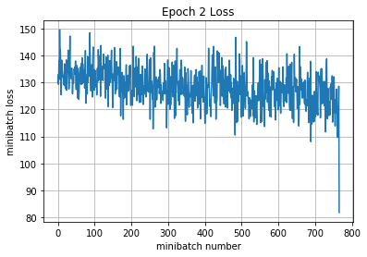

Iteration 1600: with minibatch training loss = 1.93 and accuracy of 0.27

Iteration 1700: with minibatch training loss = 1.79 and accuracy of 0.3

Iteration 1800: with minibatch training loss = 1.99 and accuracy of 0.3

Iteration 1900: with minibatch training loss = 1.76 and accuracy of 0.36

Iteration 2000: with minibatch training loss = 1.94 and accuracy of 0.25

Iteration 2100: with minibatch training loss = 1.8 and accuracy of 0.28

Iteration 2200: with minibatch training loss = 2.03 and accuracy of 0.28

Epoch 3, Overall loss = 1.89 and accuracy of 0.316

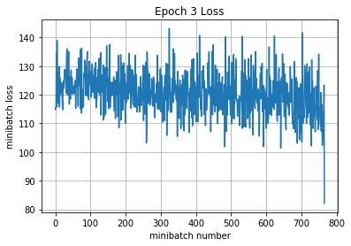

Iteration 2300: with minibatch training loss = 1.75 and accuracy of 0.38

Iteration 2400: with minibatch training loss = 1.87 and accuracy of 0.41

Iteration 2500: with minibatch training loss = 1.64 and accuracy of 0.41

Iteration 2600: with minibatch training loss = 1.71 and accuracy of 0.44

Iteration 2700: with minibatch training loss = 1.63 and accuracy of 0.39

Iteration 2800: with minibatch training loss = 1.82 and accuracy of 0.45

Iteration 2900: with minibatch training loss = 1.56 and accuracy of 0.42

Iteration 3000: with minibatch training loss = 1.82 and accuracy of 0.31

Epoch 4, Overall loss = 1.74 and accuracy of 0.376

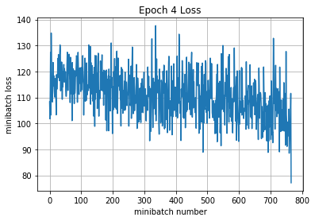

Iteration 3100: with minibatch training loss = 1.68 and accuracy of 0.36

Iteration 3200: with minibatch training loss = 1.68 and accuracy of 0.39

Iteration 3300: with minibatch training loss = 1.49 and accuracy of 0.5

Iteration 3400: with minibatch training loss = 1.78 and accuracy of 0.39

Iteration 3500: with minibatch training loss = 1.5 and accuracy of 0.42

Iteration 3600: with minibatch training loss = 1.45 and accuracy of 0.38

Iteration 3700: with minibatch training loss = 1.56 and accuracy of 0.36

Iteration 3800: with minibatch training loss = 1.43 and accuracy of 0.47

Epoch 5, Overall loss = 1.56 and accuracy of 0.44

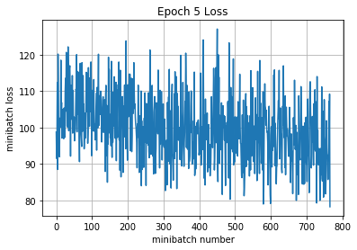

Iteration 3900: with minibatch training loss = 1.44 and accuracy of 0.53

Iteration 4000: with minibatch training loss = 1.59 and accuracy of 0.48

Iteration 4100: with minibatch training loss = 1.25 and accuracy of 0.45

Iteration 4200: with minibatch training loss = 1.32 and accuracy of 0.59

Iteration 4300: with minibatch training loss = 1.45 and accuracy of 0.45

Iteration 4400: with minibatch training loss = 1.49 and accuracy of 0.55

Iteration 4500: with minibatch training loss = 1.48 and accuracy of 0.45

Epoch 6, Overall loss = 1.46 and accuracy of 0.48

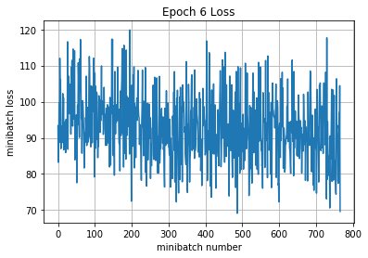

Iteration 4600: with minibatch training loss = 1.24 and accuracy of 0.52

Iteration 4700: with minibatch training loss = 1.38 and accuracy of 0.5

Iteration 4800: with minibatch training loss = 1.57 and accuracy of 0.44

Iteration 4900: with minibatch training loss = 1.44 and accuracy of 0.53

Iteration 5000: with minibatch training loss = 1.62 and accuracy of 0.44

Iteration 5100: with minibatch training loss = 1.33 and accuracy of 0.58

Iteration 5200: with minibatch training loss = 1.5 and accuracy of 0.47

Iteration 5300: with minibatch training loss = 1.42 and accuracy of 0.47

Epoch 7, Overall loss = 1.39 and accuracy of 0.504

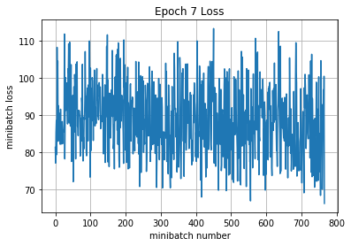

Iteration 5400: with minibatch training loss = 1.69 and accuracy of 0.55

Iteration 5500: with minibatch training loss = 1.44 and accuracy of 0.48

Iteration 5600: with minibatch training loss = 1.2 and accuracy of 0.53

Iteration 5700: with minibatch training loss = 1.52 and accuracy of 0.41

Iteration 5800: with minibatch training loss = 1.28 and accuracy of 0.53

Iteration 5900: with minibatch training loss = 1.32 and accuracy of 0.45

Iteration 6000: with minibatch training loss = 1.11 and accuracy of 0.64

Iteration 6100: with minibatch training loss = 1.3 and accuracy of 0.56

Epoch 8, Overall loss = 1.32 and accuracy of 0.528

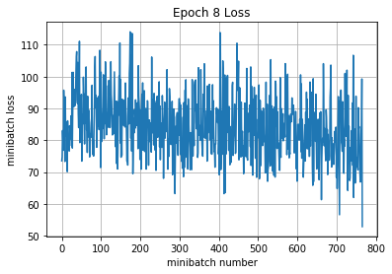

Iteration 6200: with minibatch training loss = 1.19 and accuracy of 0.59

Iteration 6300: with minibatch training loss = 1.4 and accuracy of 0.5

Iteration 6400: with minibatch training loss = 1.28 and accuracy of 0.53

Iteration 6500: with minibatch training loss = 1.1 and accuracy of 0.61

Iteration 6600: with minibatch training loss = 1.08 and accuracy of 0.58

Iteration 6700: with minibatch training loss = 1.19 and accuracy of 0.56

Iteration 6800: with minibatch training loss = 1.07 and accuracy of 0.59

Epoch 9, Overall loss = 1.21 and accuracy of 0.57

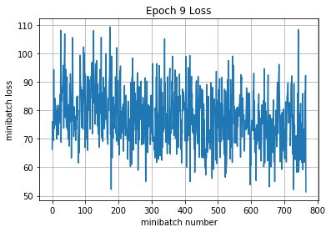

Iteration 6900: with minibatch training loss = 0.95 and accuracy of 0.77

Iteration 7000: with minibatch training loss = 1.25 and accuracy of 0.56

Iteration 7100: with minibatch training loss = 1.19 and accuracy of 0.55

Iteration 7200: with minibatch training loss = 0.958 and accuracy of 0.69

Iteration 7300: with minibatch training loss = 1.2 and accuracy of 0.56

Iteration 7400: with minibatch training loss = 1.01 and accuracy of 0.62

Iteration 7500: with minibatch training loss = 1.2 and accuracy of 0.5

Iteration 7600: with minibatch training loss = 0.771 and accuracy of 0.72

Epoch 10, Overall loss = 1.11 and accuracy of 0.61

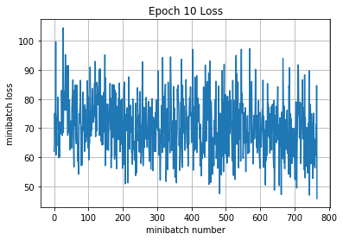

19832.265106201172

Validation

Epoch 1, Overall loss = 1.13 and accuracy of 0.593

Training

Epoch 1, Overall loss = 0.961 and accuracy of 0.661

Validation

Epoch 1, Overall loss = 1.13 and accuracy of 0.593

Test

Epoch 1, Overall loss = 1.16 and accuracy of 0.599